**Quarter 2 Project: *Indoor Riparian Ecosystem Part I***

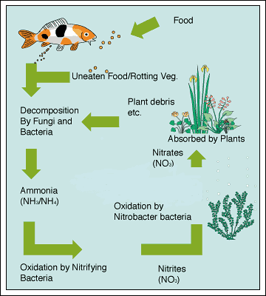For you second quarter project, you will be constructing an aquaponics system to house native fish and feed native riparian plants. Working time for part I of this project will span from December 4th until the final day of the semester, December 20th. Part II of this project will extend into the second semester.

Figure : Diagram of the nitrogen cycle within an aquaponics tank.

**Deadlines**

* Project Proposals due (12/8/23) sent to <teacher> by no later than 8pm
* Tank construction starts (12/11/23)
* Tank construction finished (12/15/23)
* Oral and written data action plan (during class 12/20/23)

*\*Part II of this project will consist of a full written report as well as a project Reflection\**

We will not have class time to work on this project 12/6, 12/13, or 12/18. You may have to come in during conference, BPH, or work at home to finish work on time.

**Project Proposal** *(25% of grade)*

* Instructor will share Project Proposal example/guidelines electronically and on paper on 12/4/23.
* Students may submit electronically or on paper.
* Proposals must include: choice of native riparian plant, proof of existence in local riparian habitat (iNaturalist referencing Santa Cruz, Sweetwater, Sabino, etc.), and reference design/schematic for tank.

**Written Data Action Plan** *(25% of grade)*

Class 12/20/23 will be the last class before the end of the semester. Your written action plan is due at the end of class today in your notebook. Since this will be an ongoing project, you must make a plan for how you will continue to collect data regarding the health of your ecosystem. You may evaluate this according to the following options:

* **Macroinvertebrate study:** Consider that ecological health is proportional to the diversity in an ecosystem. You will periodically measure the species richness and abundance of macroinvertebrates in your tank.
* **Nitrogen study:** Consider the nitrogen cycle. According to the theory of aquaponics, nitrogen must cycle through your tank system in order for your plants to be properly fed. You will periodically measure the nitrogen speciation of your tank.
* **Bacteria study:** Consider the nitrogen cycle. In order for nitrogen to properly cycle through your tank, there must exist certain bacterial species. Make a plan for how you will quantify bacterial concentration in your tank from week to week.
* **Build your own study:** Have a great idea? Run it by Mr. Kochenderfer first. It must be able to evaluate the health of your ecosystem!

To receive a grade for this section of the project, you must:

* Have a draft of the data table you will use to collect data in your notebook. It should include room for 10 weeks of data collection.
* Have a written statement for *how* you will collect data—sort of like a rough draft procedure.

**Oral Data Action Plan** *(25% of grade)*

Class 12/20/23 will be the last class before the end of the semester. During class today you and your group will have a brief conference with me about your written action plan. Think of this as like the quarter 1 project oral exam. During our conference, you and your group must convince me that you have met the following success criteria:

* Knowledge of procedures for data collection.
* Knowledges of resources to aid in data collection.
* Preparedness for collecting data.

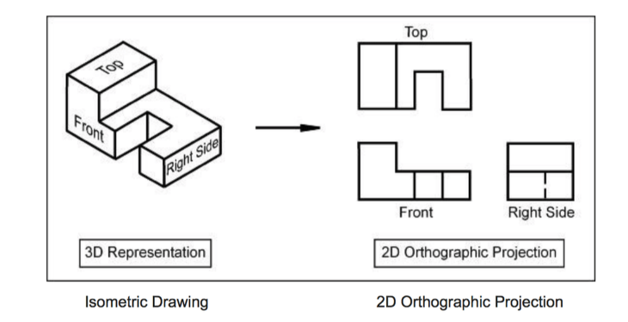Satisfying these three criteria and a self-assessment will earn you your grade for this section.

**Indoor Riparian Ecosystem** *(25% of grade)*

This grade is easy to achieve. All that is necessary is a:

* Complete, functional aquaponics tank. The tank has plant and fish life introduced as well as conditioned water (bacteria).
* Isometric drawing of tank in notebook.