**Taxonomy Lesson (BIORETS)**

**Standards:**

**Objectives:**

Students will be able to describe in their own words the purpose of taxonomy in science.

**Required Equipment/Supplies**

* Power Point
* Food Category Worksheet

**Anticipatory Set**

**Food Sorting Activity**

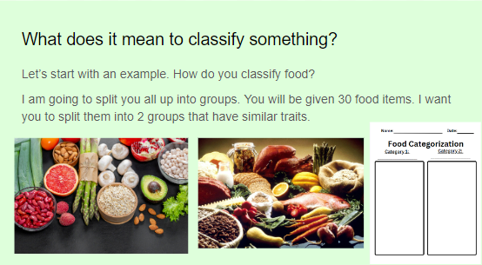

Pose the question: ‘What does it mean to classify something?’ Split students into small groups. Given 30 food items, students sort the food into two separate groups. How the food is sorted is up to the students. The food may be sorted by how the food is stored, if the food is a single ingredient, if the student likes or dislikes the food. This is a time for the students to be creative in thinking how they classify foods. Give the students 5-7 minutes to complete this activity. When the activity is completed, discuss as a class what their two categories were when doing the initial classification.

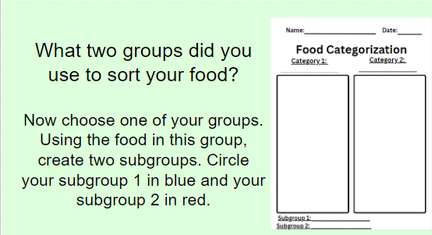

Pose the challenge: ‘Now, choose one of your groups. Using one of the groups, break the food into subgroups. Circle your subgroup 1 in blue and your sub group 2 in red. Be sure to write the subgroups on the bottom of your worksheet.’ Allow for 2-5 minutes for activity to be completed.

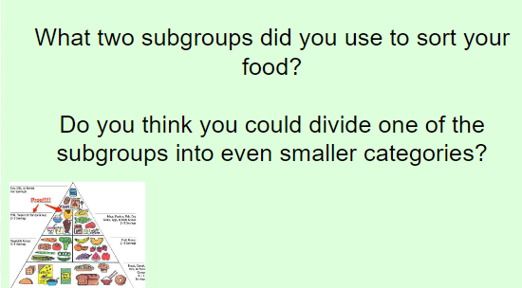

Pose the question for class discussion: ‘What two subgroups did you use to sort your foods? Do you think you could divide one of the subgroups into an even smaller category?’

*If this activity is done on paper, allow students to cut out photos of the food and glue them onto the worksheet. This activity can also be laminated and done multiples times. If you plan to grade their work, photos can be taken of their food sort for a later date.

**Direct Instruction**

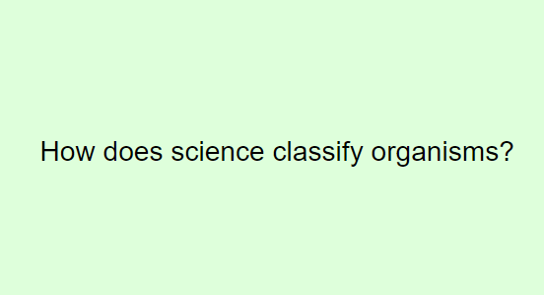

Teacher: ‘The introduction activity helped you think about how you and your partner may classify foods. Now we are going to talk about how/why scientists classify organisms.

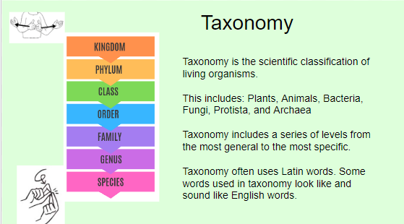

Taxonomy is the scientific classification of organisms. Living organisms include plants, animals, bacteria, fungi, protista, and archaea. In taxonomy, a series of levels are used from more general categories to more specific groupings in order to show how organisms relate and are different.

**Extension Question:** Taxonomy uses Latin words, which may look or sound like English words. Remember, Latin is considered a dead language. Why do you think that Latin is used in scientific classification?

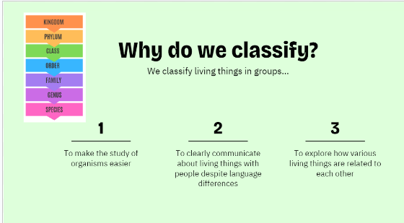

There are three reasons why you need to know that scientists choose to use taxonomy to classify animals.

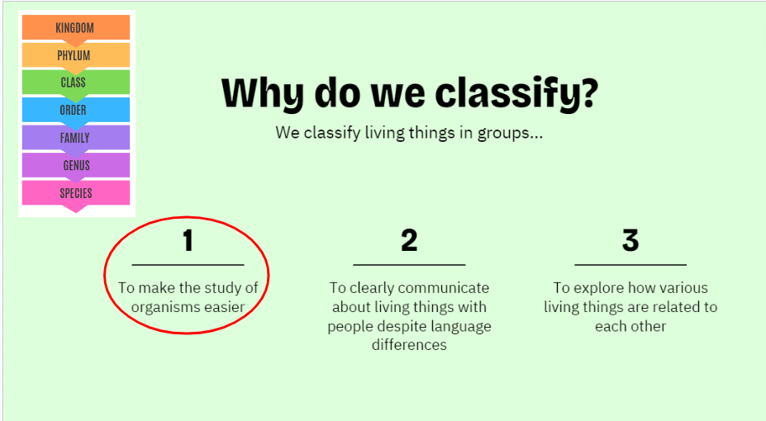

1. To make the study of organisms easier
   1. For a moment, look back at your food categorization from our warm up. The items are all food. Imagine if none of that food had specific names. How could you talk about those foods with each other if none of the food had a name?
   2. 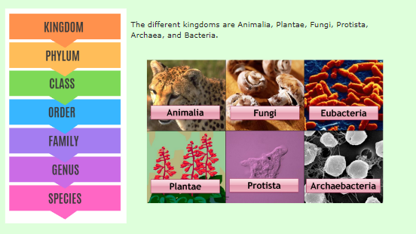Let’s start with the most broad category; Kingdom. Kingdom includes Animalia, Fungi, Protista, Archaea, and Bacteria
   3. 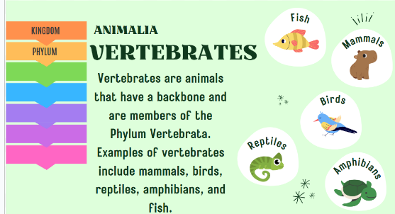Let’s look at the Animalea Kingdom and be more specific about Phylum. The Animalia Phylum we will use for our example today is vertebrates.
   4. 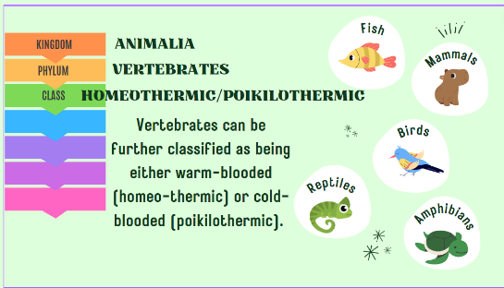Now, let’s become even more specific. Let’s look at the Class Homeothermic and Poikothermic.
   5. As we continue to move down on the Taxonomy ladder, the groupings get more specific. We will spend more time looking at specific orders, families, genus, and species later. But as we have just learned, taxonomy makes the study of organisms easier through classifications.

**Possible Extension Activity:** Look into Classification Keys

1. 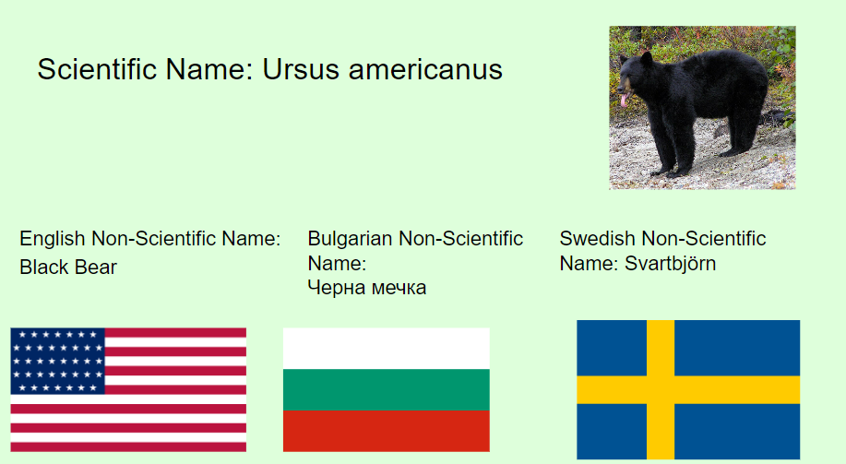To clearly communicate about living things with people despite language differences.
   1. Imagine three scientists are in a room together. One is American, one is Bulgarian, and another is Swedish. None of these scientists speak the same language. If you ask the three scientists to name the bear in this picture, they will give you the same scientific name, but a different non-scientific name.
2. To explore how various living things are related to each other
   1. 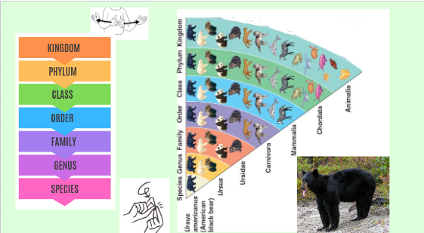Look at the black bear on screen. Look at the model next to the bear. I can tell you so much about their bear thanks to it’s taxonomy. I know that this bear is considered an animal, with a spinal cord, it is a mammal so it’s young drinks milk, and it is carnivorous, so the black bear eats meat. I know that the black bear is a bear and it’s most specific scientific name is Ursus americanus.

**Guided Instruction**

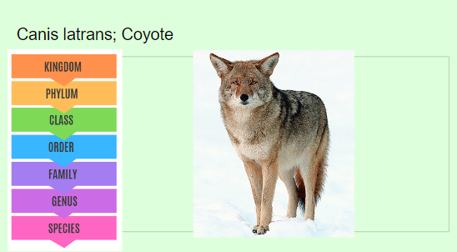We have now learned about the three reasons scientists use taxonomy in their field. Now, let’s Make our own taxonomy chart like the one I showed you for Ursus americanus. Let’s use a local organism; the Canis latrans, the coyote.

Which kingdom do you think the coyote is apart of?

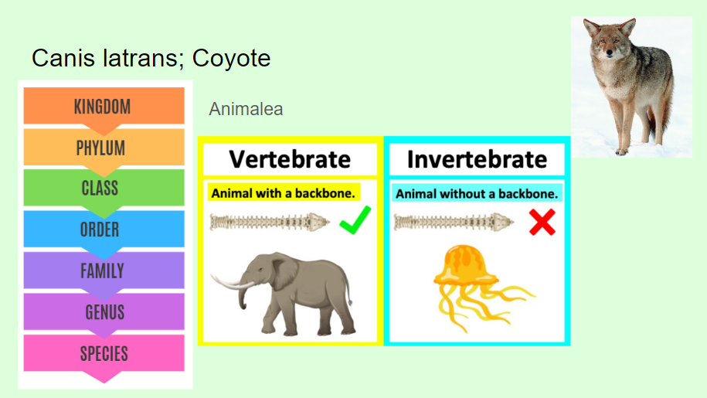

Do you think that the coyote is a vertebrate or invertebrate?

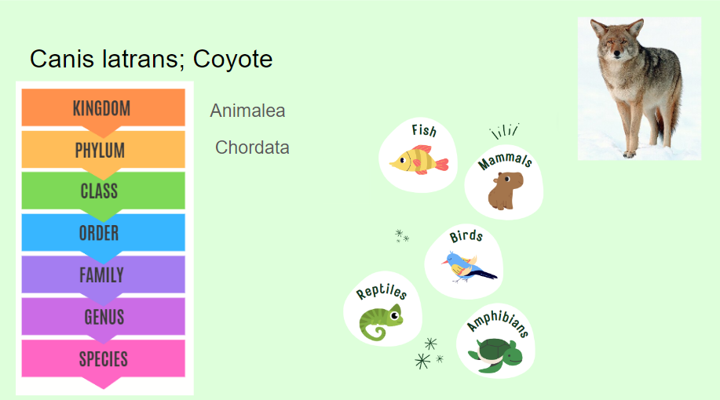

Is a coyote a fish, mammal, bird, reptile, or amphibian?

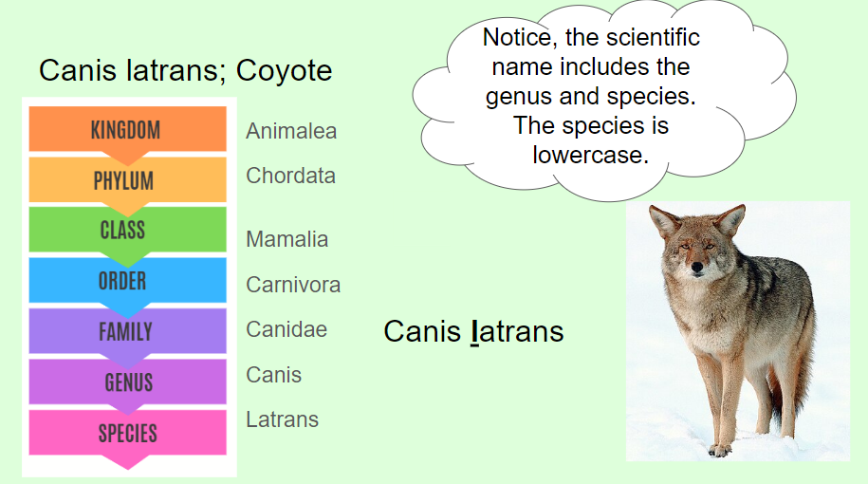

The number of possible orders and families are so many, that I will not have you guess today. Instead, I will just tell you the names of the order and family for the coyote.

I want you to look back at the scientific name. Notice, the scientific name includes the genus and species. The species is lowercase.

**Independent Learning**

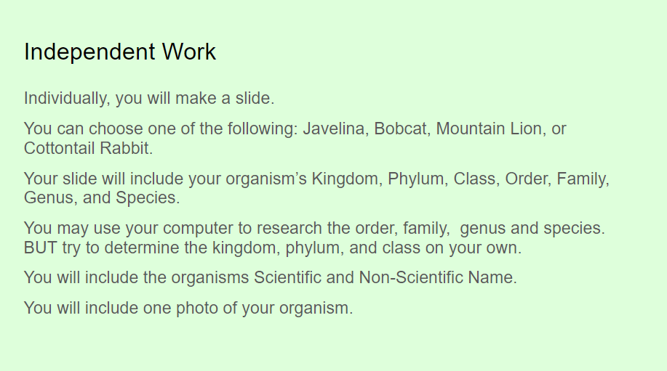

Instructions: Individually, you will make a slide. You can choose one of the following: Javelina, Bobcat, Mountain Lion, or Cottontail Rabbit. Your slide will include your organism’s Kingdom, Phylum, Class, Order, Family, Genus, and Species.

You may use your computer to research the order, family, genus and species. BUT try to determine the kingdom, phylum, and class on your own.

You will include the organisms Scientific and Non-Scientific Name.

You will include one photo of your organism.

Example Slide: 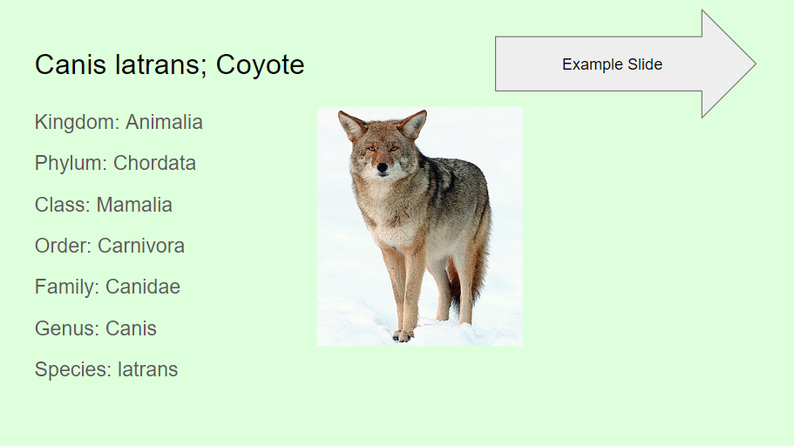

**Closing**

After you submit your slide, and before you leave class, tell me one reason scientists need to use taxonomy.

*This is an acceptable exit ticket for small classes. Larger classes can also do google class polls or written exit tickets.

**Possible Extension Activities:** Embedded in teacher guide.