Plant Identification Lab
1. Project Overview
Project Title | Plant Identification Lab | Product(s) |  | - “Zoom in-Zoom out Plant Nature Journaling  - Student Lab Report  - Data Collection Sheet  - Graphs  - Conclusion Question
Driving Questions | - How does plant species richness vary in a Sonoran Desert vs a Riparian Habitat?
Grade Level/  Subject | PCC Bio 182 - 10th & 11th Grade  Or  AP Biology
Time Frame | 2 days*  *This may take longer depending on how much time is allotted for project work in class. This plan views “students-as-workers, teachers as coaches/facilitators.”
Project Summary | Plants are a natural part of our ecosystem. By examining the distribution of plants along a transect line, in two different habitats, we can explore how patterns in organism distribution are related to environmental conditions. Species richness is the number of different species represented in an ecological community, landscape or region. This lab will utilize scientific methods to measure and examine the total number of plants for two different environmental conditions (Desert vs. Riparian Habitat). This lab will consist of two parts. The first part will require students to collect data using a transect line (50m), where students will count the total number of different species of plants in set quadrants (1m²) located every 5 meters along a transect line, at their local school. The second part will examine pre-collected transect data conducted along the Santa Cruz River. This lab will examine how species richness varies across these two respective habitats.

2. Learning Goals
Learning Objectives | - SWBAT understand the significance of a phenomenon is dependent on the scale, proportion, and quantity at which it occurs.  - SWBAT understand how patterns in the natural world can be observed, used to describe phenomena, and used as evidence.  - SWBAT describe how different ecosystems support diverse life forms. |  | PCC Bio 182  Performance Outcomes |  | - Describe how different ecosystems support diverse life forms.  - The structure of a community can be measured and described in terms of species composition and species diversity.
AZ State Standards | Cross-Cutting Standards:  - The significance of a phenomenon is dependent on the scale, proportion, and quantity at which it occurs.  - Patterns in the natural and human designed world can be observed, used to describe phenomena, and used as evidence.  - Different patterns may be observed at each of the scales at which a system is studied and can provide evidence for causality in explanations of phenomena.  - Mathematical representations are needed to identify some patterns.  - Empirical evidence is needed to identify patterns. |  | Resources: |  | - https://aznps.com/the-plant-list/

3. Project Milestones
Milestone #1  Entry Event (1 day) | Milestone #2  (2nd Day)
- Plant Nature Journaling (Zoom In-Zoom Out)  - Sonoran Desert Plant Data Collection at local school site.  - Data Analysis of Sonoran Desert vs Riparian Habitat Plants | - Data Analysis of Sonoran Desert vs Riparian Habitat Plants (cont.)  - Graphing of Species Richness  - Analysis Questions
Key Student Questions | Key Student Questions
- Nature Journaling  - What kinds of details do you notice when you are up-close? Far-away?  - How does shifting your perspective on something change the way you think about it?  - Are there structures you’re seeing in the magnified view that are similar to structures you see in the distant view? How are they alike and different?  - How might the size of a structure affect how it functions?  - What things in the surrounding environment might impact or influence the subject of your journal entry? Can you see evidence of this?  - Can you come up with any explanation, based on evidence, about how the environment influences and interacts with your subject?  - Sonoran Desert Plant Transect Data Collection  - What could account for any changes in plant species richness observed along each group’s transect line? Between Groups?  - What trends/patterns were identified in plant species richness along the transect line? (Group and Class)  - Data Analysis (Graphing & Conclusion Questions)  - What overall trends/patterns were observed in species richness along the transect lines for a Desert and a Riparian Habitat?  - What are the differences & similarities in plant species richness in a Southern Arizona Riparian vs Desert habitat?  - Which habitat had the highest amount of plant species richness? Explain your results  - What factors (abiotic/biotic) might lead to the observed changes in richness you observed between the Sonoran Desert and the Riparian Habitat?  - How do the diverse ecosystems support increased biodiversity? | Data Analysis (Graphing & Conclusion Questions)  - What overall trends/patterns were observed in species richness along the transect lines for a Desert and a Riparian Habitat?  - What are the differences & similarities in plant species richness in a Southern Arizona Riparian vs Desert habitat?  - Which habitat had the highest amount of plant species richness? Explain your results  - What factors (abiotic/biotic) might lead to the observed changes in richness you observed between the Sonoran Desert and the Riparian Habitat?  - How do the diverse ecosystems support increased biodiversity?
Formative Assessment(s) | Summative Assessment(s)
- Group Think-Pair-Share (I notice, I wonder, It reminds me of) - partner share  - Self Reflection Question | - Reflection Questionnaire Completion  - Self Reflection Question

4. Project Calendar
Driving Question: How does plant species richness vary in a Sonoran Desert vs a Riparian Habitat?
Day 1: | Day 2:
LEARNING TARGET/OUTCOME:  - SWBAT understand the significance of a phenomenon is dependent on the scale, proportion, and quantity at which it occurs.  - SWBAT understand how patterns in the natural world can be observed, used to describe phenomena, and used as evidence.  LESSON  - Zoom-in/Zoom-out Plant Nature Journaling  - Students will record observations of a single plant at three different scales: close-up, lifesize, and far away  - Students will use writing, drawings, and numbers to record their observations  - Reflection Questions:  - What kinds of details do you notice when you are up-close? Far-away?  - How does shifting your perspective on something change the way you think about it?  - Are there structures you’re seeing in the magnified view that are similar to structures you see in the distant view? How are they alike and different?  - How might the size of a structure affect how it functions?  - What things in the surrounding environment might impact or influence the subject of your journal entry? Can you see evidence of this?  - Can you come up with any explanation, based on evidence, about how the environment influences and interacts with your subject?  - Sonoran Desert Plant Transect Data Collection  - Students will collect data, in a group, along a 50 meter transect line of their choosing. Students will record the name of each individual plant located within a quadrant (dimensions of quadrant: 1 meter square). Quadrants will be located every 5 meters along the transect line for a total of 10 quadrants (starting at 2.5 meters and ending at 47.5 meters). Each group will end up with a different transect line and a different set of data points depending on where they placed their transect line.  - Sonoran Desert Plant Data Analysis  - Students will construct & analyze data on plant richness data, for the Sonoran Desert Habitat, by making a bar graph (1 per group) of species richness (y-axis) for their group’s transect line (x-axis = transect line points). Students will obtain data by counting the total number of different plant species located along their transect line. They will obtain their data by adding up the total number of different species they observed along their transect line (each different species will only be counted once)  - Students will construct & analyze data on plant richness, for the entire Sonoran Desert, by making a bar graph of the total number of different species for each transect line by utilizing the whole class's data. Students will obtain data by counting the total number of different species for each individual transect line and graphing the total number of species (species richness, y-axis) for each individual transect (individual transects, x-axis).  SUPPLIES: Quadrant (or hula hoop), Transect Tape  SCAFFOLDS  - Students will be given a pre-made graphic organizer to help them graph the data they collected in this lab.  *Additional Scaffolds will be given based on student needs  FORMATIVE ASSESSMENT  - Describe how the environment interacted with your “subject” in the nature journaling activity.  - What could account for any changes in plant biodiversity observed along each group’s transect line? Between Groups?  - What trends/patterns were identified in plant biodiversity along the transect line? (Group and Class)  REFLECTION/CLOSURE:  What do you predict is going to happen with species richness for the Riparian Habitat? | LEARNING TARGET/OUTCOME  - SWBAT understand how patterns in the natural world can be observed, used to describe phenomena, and used as evidence.  - SWBAT describe how different ecosystems support diverse life forms.  LESSON  - Riparian Habitat Plant Data Analysis  - Students will construct & analyze data on plant richness, for the entire Riparian Habitat, by making a graph on total species richness/transect. Students will use pre-collected data from a Riparian Habitat along the Santa Cruz River. Students will be given a choice on which location (along the Santa Cruz River) their group prefers. All Riparian Habitat data was pre-collected during the summer of 2024 in the University of Arizona’s BIORETS program (available options = 5 different locations, 6 transects per location). Students (done in groups) will obtain data by counting the total number of species for each individual transect line and graphing the total number of different species (y-axis) for each individual transect (x-axis; 6 transects total). Since each group will be given the option of examining 1 of 5 different locations along the Santa Cruz River, data analysis will vary, per group. depending on which location each group chooses.  - Sonoran Desert vs. Riparian Habitat Data Analysis and conclusion questions  - Students will construct & analyze data on plant biodiversity/plant richness, for the Sonoran Desert vs. Riparian Habitat, by making a graph on total species richness (y-axis)/transect point (x-axis) for both ecosystems. Students will use the whole class's data (for the Sonoran Desert Habitat) and compare it to their group’s Riparian Habitat data. Riparian data will vary per group as each group will be given a choice on which location they are using for their data analysis (5 locations total). Students will obtain data by counting the total number of species for each individual transect line and graphing the total number of different species or species richness (y-axis) for each individual transect point (x-axis).  - Conclusion Questions:  - What overall trends/patterns were observed in species richness along the transect lines for a Desert and a Riparian Habitat?  - What are the differences & similarities in plant species richness in a Southern Arizona Riparian vs Desert habitat?  - Which habitat had the highest amount of plant species richness? Explain your results  - What factors (abiotic/biotic) might lead to the observed changes in richness you observed between the Sonoran Desert and the Riparian Habitat?  - How do the diverse ecosystems support increased biodiversity?  SUPPLIES: Quadrant (or hula hoop), Transect Tape  SCAFFOLDS  - Students will be given a pre-made graphic organizer to help them graph the data they collected in this lab.  *Additional Scaffolds will be given based on student needs  FORMATIVE ASSESSMENT  - What overall trends/patterns were observed in species richness along the transect lines for a Desert and a Riparian Habitat?  - What are the differences & similarities in plant species richness/biodiversity in a Southern Arizona Riparian vs Desert habitat?  - Which habitat had the highest amount of plant biodiversity? Species richness? Explain your results.  - What factors (abiotic/biotic) might lead to the observed changes in richness you observed between the Sonoran Desert and the Riparian Habitat?  - How do the diverse ecosystems support increased biodiversity?  REFLECTION/CLOSURE:  What was most surprising about the data

4. Project Instructions
ZOOM-IN/ZOOM-OUT NATURE JOURNALING
Objective: SWBAT understand the significance of a phenomenon is dependent on the scale, proportion, and quantity at which it occurs.
Assignment: Zoom-in/Zoom-out Nature Journaling
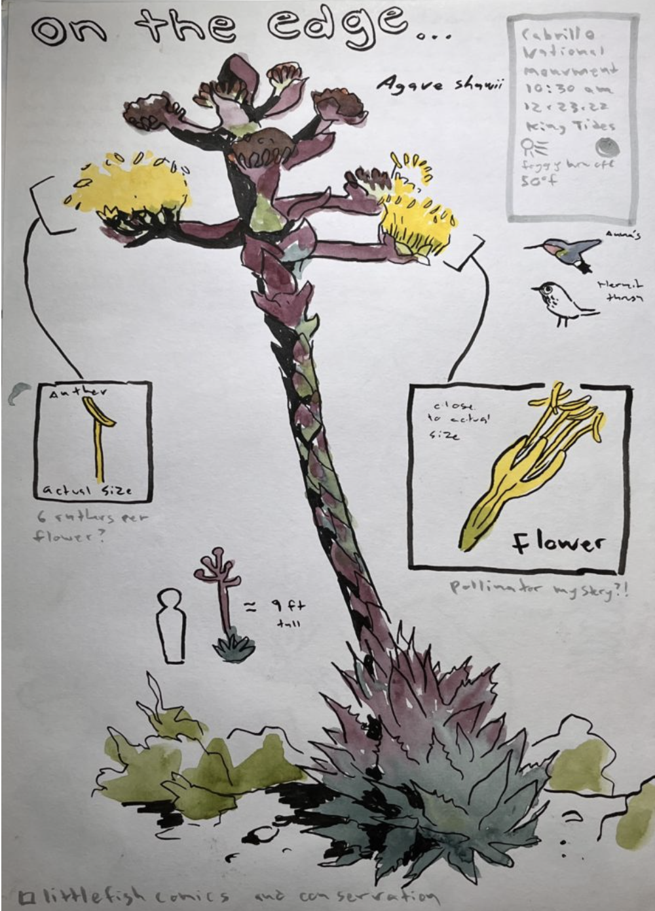
Instructions:
- Zoom-in/Zoom-out Plant Nature Journaling
  - Students will record observations of a single plant at three different scales: close-up, lifesize, and far away
    - Students will use writing, drawings, and numbers to record their observations
    - Students should use circles to show the magnified view for the “Zoomed-in” portion of this exercise.
    - Students should include details such as growth forms, where the subject is, or a small map for the “Zoomed-out” portion of this exercise.
  - Reflection Questions:
    - What kinds of details do you notice when you are up-close? Far-away?
    - How does shifting your perspective on something change the way you think about it?
    - Are there structures you’re seeing in the magnified view that are similar to structures you see in the distant view? How are they alike and different?
    - How might the size of a structure affect how it functions?
    - What things in the surrounding environment might impact or influence the subject of your journal entry? Can you see evidence of this?
    - Can you come up with any explanation, based on evidence, about how the environment influences and interacts with your subject?

Sonoran Desert Plant Transect Data Collection
Objective: SWBAT understand how patterns in the natural world can be observed, used to describe phenomena, and used as evidence.
Assignment: Sonoran Desert Plant Transect Data Collection

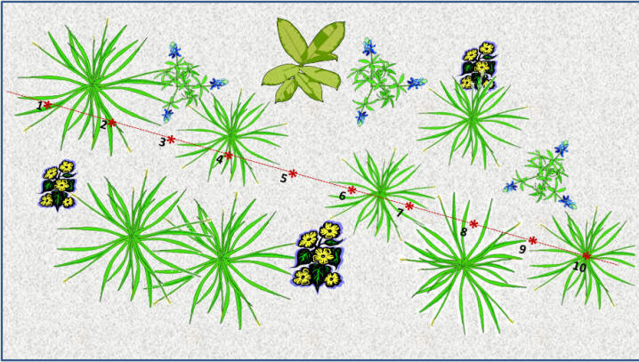
Instructions:
- Students will collect data, in a group, along a 50 meter transect line of their choosing.
- Students (1 per group) will record the name of each individual plant located within a quadrant (dimensions of quadrant: 1 meter square).
  - Quadrants will be located every 5 meters along the transect line, for a total of 10 quadrants (starting at 2.5 meters) along each transect line; transect line = 50 meters total.
- Each group will end up with a different transect line and a different set of data points depending on where they placed their transect line.
- Students should notate on their graphic organizer every species of plant, tree, or shrub they find, in each quadrant, along the transect line.

Notes:

Sonoran Desert Habitat Data Analysis
Objective:
- SWBAT understand how patterns in the natural world can be observed, used to describe phenomena, and used as evidence.
- SWBAT describe how different ecosystems support diverse life forms.
Assignment: Sonoran Desert Habitat Data Analysis

Instructions:
Group Data Analysis
- Students will analyze data on plant richness data, for the Sonoran Desert Habitat, by making a histogram (1 per group) of species richness (y-axis) for their group’s transect line (x-axis = quadrant points along transect, 10 total).
- Students will obtain data by counting the total number of different plant species located in each quadrant (located every 5 meters) along their group’s entire transect (50 meters)
  - Students will end up with 10 data points (1 for each quadrant = x-axis) for the entire transect.
    - Quadrant points along the transect are as follows: 1 = 2.5m, 2 = 7.5m, 3 = 12.5m, 4 = 17.5m, 5 = 22.5m, 6 = 27.5m, 7 = 32.5m, 8 = 37.5m, 9 = 42.5m, 10 = 47.5
  - *Each group will have a unique set of data points depending on where they placed their transect line.
- Students will make a histogram representing the total species richness (y-axis) per quadrant over the entire transect line.

Class Data Analysis:
- Students will analyze data on plant richness, for the entire Sonoran Desert, by making a graph of the total number of different species (i.e. species richness) per transect line by utilizing the whole class's data.
- Students will obtain data by counting the total number of different species for each individual transect line and graphing the total number of species (species richness, y-axis) for each individual transect (individual group transects, x-axis, number of points depends on # of groups in class).

Riparian Habitat Data Analysis
Objective:
- SWBAT understand how patterns in the natural world can be observed, used to describe phenomena, and used as evidence.
- SWBAT describe how different ecosystems support diverse life forms.
Assignment: Riparian Habitat Data Analysis

Instructions:
- Students will construct & analyze data on plant biodiversity/plant richness, for the Sonoran Desert vs. Riparian Habitat, by making a graph on total species richness (y-axis)/transect point (x-axis) for both ecosystems.
- Students will use the whole class's data (for the Sonoran Desert Habitat) and compare it to their group’s Riparian Habitat data.
  - * Riparian data will vary per group as each group will be given a choice on which location they are using for their data analysis (5 locations total).
- Students will obtain data by counting the total number of species for each individual transect line and graphing the total number of different species or species richness (y-axis) for each individual transect point (x-axis)

Sonoran Desert vs. Riparian Habitat Data Analysis
Objective:
- SWBAT understand how patterns in the natural world can be observed, used to describe phenomena, and used as evidence.
- SWBAT describe how different ecosystems support diverse life forms.
Assignment: Sonoran Desert vs. Riparian Habitat Data Analysis

Instructions:
- Students will construct & analyze data on plant biodiversity/plant richness, for the Sonoran Desert vs. Riparian Habitat, by making a graph on total species richness (y-axis)/transect point (x-axis) for both ecosystems.
- Students will use the whole class's data (for the Sonoran Desert Habitat) and compare it to their group’s Riparian Habitat data.
  - *Riparian data will vary per group as each group will be given a choice on which location they are using for their data analysis (5 locations total).
- Students will obtain data by counting the total number of species for each individual transect line and graphing the total number of different species or species richness (y-axis) for each individual transect point (x-axis).

Conclusion Questions:
- What overall trends/patterns were observed in species richness along the transect lines for a Desert and a Riparian Habitat?
- What are the differences & similarities in plant species richness in a Southern Arizona Riparian vs Desert habitat?
- Which habitat had the highest amount of plant species richness? Explain your results
- What factors (abiotic/biotic) might lead to the observed changes in richness you observed between the Sonoran Desert and the Riparian Habitat?
- How do the diverse ecosystems support increased biodiversity?

Sample Student Works:
Paste student work here

