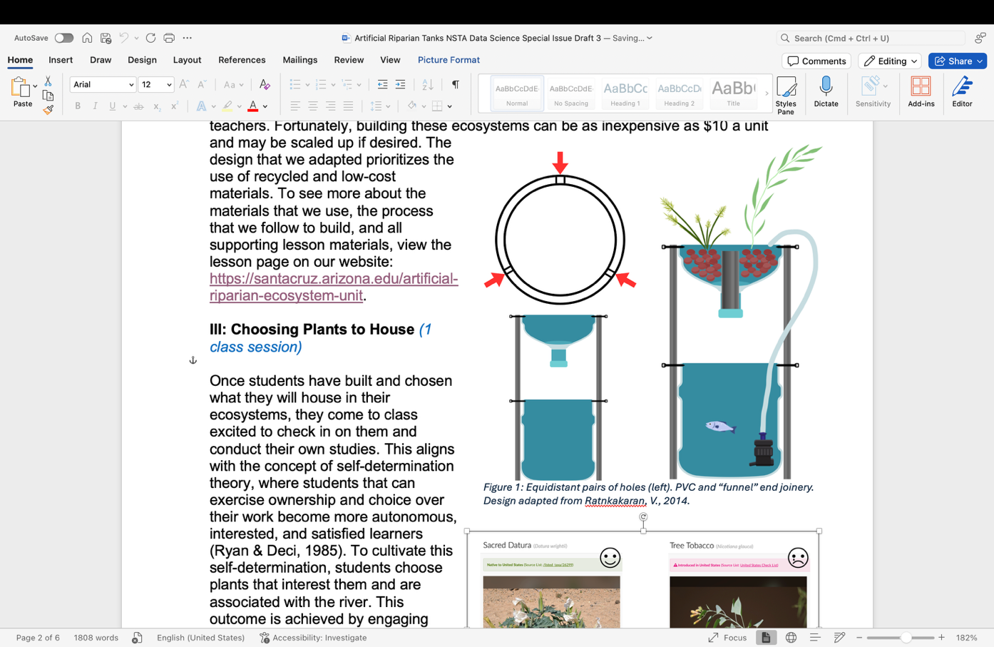
Project: Artificial Ecosystem Health Technical Report
For this report, you will qualify the health of your ecosystem, support this claim with evidence you have collected, and describe the methodology for collecting evidence. This must be organized into a technical report and submit to [system] by [date/time]. Please format your report using the “Sample Report Template” (below).
Deadlines
- Project begins [date]
- Report is due [date approximately 2 months later]
Grading
Students will be assessed according to the following rubric. Students are encouraged to include work produced in Milestone 1, Milestone 2, Milestone 3, and Milestone 4 as supporting information in their report.
Category | N/A (0 pts) | Beginning (1 pt) | Approaching (2 pts) | Meeting (3 pts)
Abstract* | Abstract is missing all the following:  - Background  - Results  - Methods | Abstract is missing two of the following:  - Background  - Results  - Methods | Abstract is missing one of the following:  - Background  - Results  - Methods | Abstract discusses background, results, and methods.
Methods* | Report does not include discussion of methods. | Methods are vague. Difficult to replicate experiment. | Methods are detailed enough to replicated with some assistance. | Methods are detailed. This experiment could be replicated easily.
Results* | Report does not explicitly describe results. | Results are described but are not explicitly presented. | Results are explicitly described but are incomplete. | Most important findings are completely and explicitly described.
Discussion* | Report does not discuss results. | Results are discussed but is missing two of the following:  - Experimental error  - Limitation of methods  - Connection to scientific principles | Results are discussed but is missing one of the following:  - Experimental error  - Limitation of methods  - Connection to scientific principles | Results are discussed thoroughly with mention of experimental error, limitation of methods, and connection to scientific principles
Language** | Language is informal or has numerous grammar and spelling errors. | Language is occasionally informal or has the occasional grammar and spelling error. | Language is mostly formal or has few grammar and spelling errors. | Language is formal, written in passive voice, and has no grammar spelling issues.
Claim** | Report does not present an accurate central claim. | Report presents an inaccurate central claim. | Report presents an accurate, but incomplete central claim. | Report presents an accurate and complete central claim.
Evidence** | Report does not explicitly identify evidence to support claim. | Report explicitly identifies inappropriate evidence or evidence that does not support the claim. | Report explicitly identifies appropriate, but insufficient evidence. May include some inappropriate evidence. | Report explicitly identifies appropriate and sufficient evidence to support central claim.
Reasoning** | Report does not provide reasoning that links the claim to the evidence. | Report does not provide reasoning is not appropriate. | Report provides reasoning that links claim to evidence. Evidence is repeated or scientific principles are cited, but not sufficient. | Report provides accurate and complete reasoning that links the evidence to the claim. Includes appropriate and sufficient scientific principles.
Total: (__/24)
*Evidence collected within section.
**Evidence collected throughout report.
Sample Report Template
Artificial Ecosystem Report
Abstract
In this experiment, the rate at which plants in the aquaponic tank would grow was measured. This was measured by measuring the plants on top of the tank with a ruler and observing the creatures and plants in the tank. Cyperus eragrostis grew the most but Persicaria lapathifolia was a close second. Though Cyperus eragrostis is native to the southwestern U.S., most grasses grow fast so its rapid growth could be attributed to that.
Results & Discussion
Cyperus eragrostis grew the fastest due to it being native to Arizona and a grass. Persicaria lapathifolia is considered native to Arizona, and it does well in moist places, so it makes a good fit for aquaponics. Nasturtium officinale was introduced to Arizona, Nasturtium officinale is an aquatic plant so growing in aquaponics could support it well. It grew steadily and towards the end of our observations had a jump up in growth.
With the introduction of water from the river, many things started appearing, such as Lemna minor bugs and snails, and little sprouts growing from the bottom of the tank.
Lemna minor is not a native species to Arizona but when it was introduced it spread throughout the tank rapidly. The Lemna minor began to get brown and reduced the amount that was in the tank. The small sprouts rapidly spread as well but by week 8 they had all disappeared. It was sporadic when bugs were there but were recorded whenever they were seen, that goes for all the sizes of snails too, sometimes there was lots to see and sometimes there was none.

Table 1: Growth of plants and animals occupying the tank
 |  | W1 | W2 | W3 | W4 | W5 | W6 | W7 | W8 | W9 | W10
Cyperus eragrostis (cm) |  | 16.3 | 16.3 | 16.7 | 17.3 | 18.1 | 21.5 | 24.2 | 27.2 | 27.5 | 27.5
Persicaria lapathifolia (cm) |  | 7 | 7 | 10.6 | 11.5 | 12.8 | 14 | 14.1 | 14.4 | 17 | 17
Nasturtium officinale (cm) |  | 1.8 | 1.8 | 2.2 | 3 | 3.3 | 3.3 | 4 | 4.3 | 4.5 | 8
Lemna minor (%) |  | 0% | 0% | 8% | 8% | 6% | 5% | 5% | 6% | 5% | 5%
Bug |  | 0 | 0 | 1 | 1 | 0 | 1 | 1 | 0 | 0 | 0
Bug on wall |  | 0 | 0 | 1 | 1 | 0 | 0 | 0 | 0 | 0 | 1
Tiny Snail |  | 0 | 0 | 0 | 0 | 1 | 3 | 4 | 2 | 0 | 8
Small sprouts (%) |  | 0% | 0 | 0 | 0 | 12% | 12% | 10% | 0% | 0% | 0%
Teen tiny snail |  | 0 | 0 | 0 | 0 | 0 | 0 | 0 | 0 | 1 | 0
Snail |  | 0 | 0 | 2 | 1 | 0 | 1 | 0 | 0 | 0 | 0

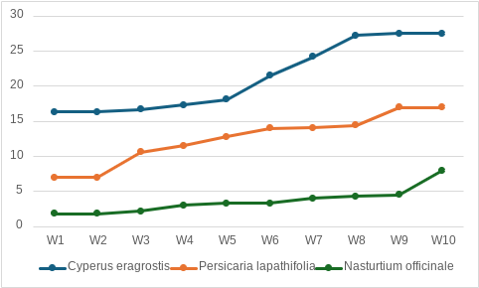
Graph 1: Measures of plant growth
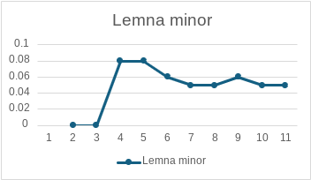
Graph 2: % of Lemna minor on top of water

Methods
To conduct this experiment aquaponic tanks were observed to determine how the chosen plants were growing. Every week the data about the plants, water and state of the tank were recorded on a piece of paper. The plants were measured with a ruler in centimeters(cm) and written as such. The state of the tank was estimated by observation; the fish, snails, sprouts growing from the bottom, and Lemna minor and written in percentages.

