**Archeology of Trash**

**Pre-Lab**

Box 1



1. Hypothesize about what kind of questions you could answer about people based on their trash? What kinds of evidence would provide answers?



**Lab**

Below, graph what your group finds in the trash. Remember to include at least three categories.

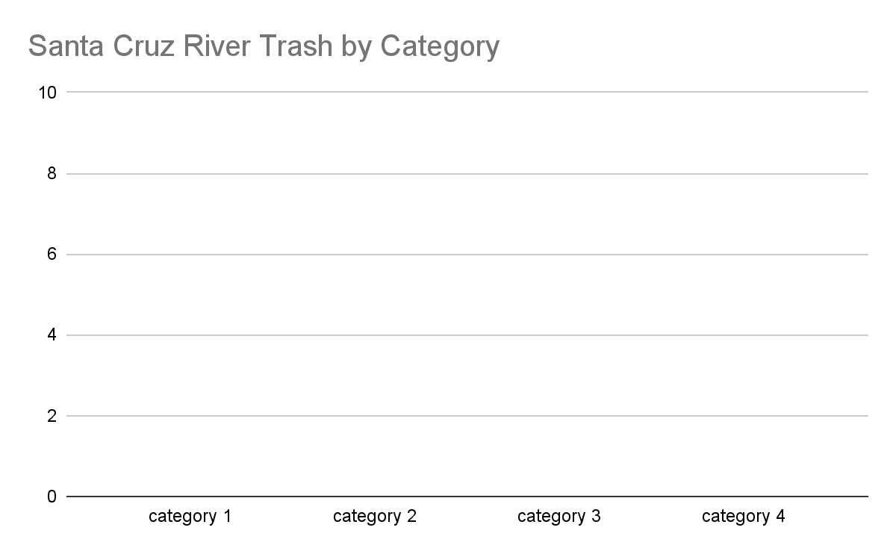

**Conclusion**

Were you able to answer your questions about the people who threw away this trash?

What evidence supports your answers?

What other conclusions can you draw about the people who left this trash behind?