Be a Friend to Trees - Tree Equity Project

Overview:
Students will learn about the benefits of trees and how they mitigate the Heat Island Effect. Students measure canopy cover at two different sites (or areas at school) and analyze the data to determine if the site meets the Tree Equity Score for urban areas and Tucson City’s urban canopy goal.

Grades:
3-5, can be adapted for grades 6-12

Timeline:
4 lessons and a reflection
Four to Five 50-minute class periods, surveys should be done preferably when canopy is abundant Aug.-Dec. or Apr.-May

Potential Community Partners:
Tucson Clean & Beautiful, COT Storm to Shade

Standards:

5.L4U3.11 Obtain, evaluate, and communicate evidence about how natural and human-caused changes to habitats or climate can impact populations.

4.L4U1.11 Analyze and interpret environmental data to demonstrate that species either adapt and survive or go extinct over time.

3.L1U1.6 Plan and carry out investigations to demonstrate ways plants and animals react to stimuli.

Objectives:
By the end of this unit, students will:
- Understand the value and benefits of tree services (shade, oxygen, reduced energy output, lower temperatures, etc)
- Understand the causes and effects of heat islands in urban areas
- Explain tree equity scores and their importance
- Describe canopy coverage at a site or between multiple sites
- Calculate percent canopy coverage at a site (area based on geometric shapes)
- Design a plan for increasing canopy coverage

Materials:
Computers, if available
Google maps or other Satellite-based map app
Clipboards
Pencils
Densiometer (spherical or hand-made) OR 100 square grid paper, copied regular paper or clear transparency sheet
Long tape Measures
Data Collection Sheet
Chart Paper
Calculators

Vocabulary:
Tree Services (benefits), Heat Island Effect, Evapotranspiration, Tree Equity Score, Canopy, Survey, Percent, Densiometer, Grid

Lesson 1: Benefits of trees
This lesson is an introduction to trees and allows students to brainstorm their benefits, learn the Heat Island Effect, and Tree Equity.
- Think-Pair-Share ~10 min: Students will brainstorm the benefits of having trees in their community, school, home, etc. and write or draw in their journals. Students will share with a partner and choose what to share out.
  - Record responses on chart paper.
- Read Be a Friend to Trees by Patricia Lauber. Read aloud here. ~15 min.
  - Students will add any new tree benefits to their journals.
  - Introduce the term Tree Services and explain that those are all the benefits that trees provide. Have students add Tree Services to their topic sentence at the top of their T-P-S in their journal.
    - Shade, rainfall capture/reduced erosion, carbon capture/oxygen, air quality
- What happens when we don’t have trees? Students T-P-S in their journals, share out. Teacher will record on a new chart paper. ~20 min.
  - Introduce Heat Island Effect: Video, article, or both.
    - Urban Heat Island Effect
    - Read and annotate article https://science.nasa.gov/kids/earth/what-is-an-urban-heat-island/
    - Discuss and highlight Evapotranspiration and how that helps urban environments.
  - Introduce Tree Equity
    - https://climateaction.tucsonaz.gov/pages/milliontrees-tree-equity
  - Students will add what they’ve learned about the Heat Island Effect, evapotranspiration and Tree Equity to their notes. The teacher will add it to the chart paper.
- Introduce the next lesson: What do you think is involved in measuring tree canopy/shade cover?

Lesson 2: Observing canopy from images
Students will observe vegetation and canopy cover from above through satellite images and make canopy coverage comparisons in two different areas of the city.
- Quick review of Tree Services ~5 min.
- Think, Pair, Share ~10 min: Students create a new TPS chart in their journals. Divide students in groups of 3-4. Show students two images of canopy cover in different neighborhoods/areas of the city. Have students write down what they noticed about both images.
  - Looking at the distribution of trees, what does that tell you about these two different neighborhoods?
  - How do the colors, shapes and patterns allow you to distinguish between the different land cover features on the earth?
  - Based on what you learned in Lesson 1, which image would you prefer, represents the tree coverage you want to see in your city?
- Students will estimate canopy cover based on the satellite images. Can use i-Tree Canopy after students estimate.
  - Students may identify features as tree/not tree
  - K-2 modification: none, some, most, all
  - 3-5: use JML canopy cover estimation tool
- Introduce Next Lesson:
  - How does our site or the neighborhood around our site compare to the land cover we see in these satellite images?
Are there more trees around our site or the surrounding area?
What would you guess is the percentage of tree canopy coverage at our site?

Lesson 3: Determine canopy cover from the ground

Teacher Prep:

Creating Satellite Sections of Your School
You will need to divide your site up into different sections and create an image for each one. When dividing up the school to create different sections, remember the following:
• Only create sections that have trees.
• If possible, try to have about the same number of trees in each section.
• The number of sections will determine the number of student groups.

Create each section by doing the following:
• Go to https://www.google.com/maps.
• Type in the address of the site to do a search.
• Click on “earth” in the lower left corner.
• Zoom in to indicate a section.
• Print the section.

Determining the Total Area for Each Section Created

Determine the area of each section by doing the following;
• Go to http://www.freemaptools.com/area-calculator.htm
• Type in the address of the site.
• Use the dropdown menu in the upper right corner and select “satellite”.
• Click on the corners of a section to indicate the total area being measured.
• The total area will appear under “Area Output" as m2.
Put this information on each of the section maps.
Assign a number to each of the section maps.

K-2 - Canopy cover of individual trees

Students will measure canopy cover by looking straight up under a tree to observe how much sky is hidden by leaves.
- Students will collect canopy data using a clear clipboard and a grid sheet to act as a simplified densiometer. Give each pair of students a clear plastic clipboard with a 10-column by 10-row grid taped to it (creating exactly 100 squares total). Explain that each single square represents 1% of their total view.
- Take the class outside to a designated area with a few scattered trees. Have student pairs stand directly underneath the center of a tree's branches, holding their grid flat and looking straight up through the plastic toward the sky.
  - Instruct one student to hold the grid steady while the partner uses a dry-erase marker to dot every square that is mostly filled with leaves or branches. For example, if a square is more than half full of leaves, it gets a dot.
- Return to the classroom to calculate the final canopy cover. Because the grid has exactly 100 squares, the math is straightforward for elementary learners:
  - Number of dotted squares = Canopy Cover Percentage

3-5 - Percent Canopy cover of site
Define the Canopy Drip Line
Explain that the perimeter of a tree's canopy is called the drip line (where rain drips off the outermost leaves). In urban forestry, this area is modeled using geometric shapes to simplify complex calculations.
- Isolated trees are modeled as circles.
- Overlapping tree clusters or rows are modeled as rectangles or trapezoids.
Field Measurement: The Circle Method
Take students outside to measure an isolated, round tree canopy.
- Have two students stand at opposite outer edges of the tree's shade, stretching a tape measure through the center of the trunk.
- This measurement gives the diameter (d) of the canopy.
- Divide the diameter by 2 to find the radius (r).
- Formula: Use the area of a circle to find the canopy square footage:
Area=$Π$r^2
Field Measurement: The Irregular Shape Method
For asymmetrical trees or clusters, have students approximate the canopy as a rectangle or a combination of triangles.
- Rectangle: Measure the length of the longest drip line axis and the width of the perpendicular axis.
- Formula:
Area=length x width
Mapping and Calculating Total Cover
Give students a piece of graph paper representing a 100 ft × 100 ft study area (10,000 sq ft total site area).
- Students plot their measured shapes onto the grid.
- Add up the areas of all measured trees to find the Total Canopy Area.
- Calculate the area of the entire school.
- Calculate the final Canopy Cover Percentage using this ratio:
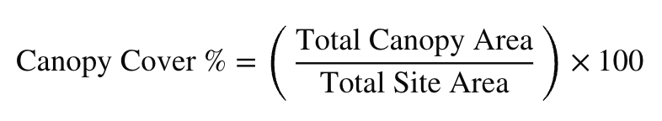
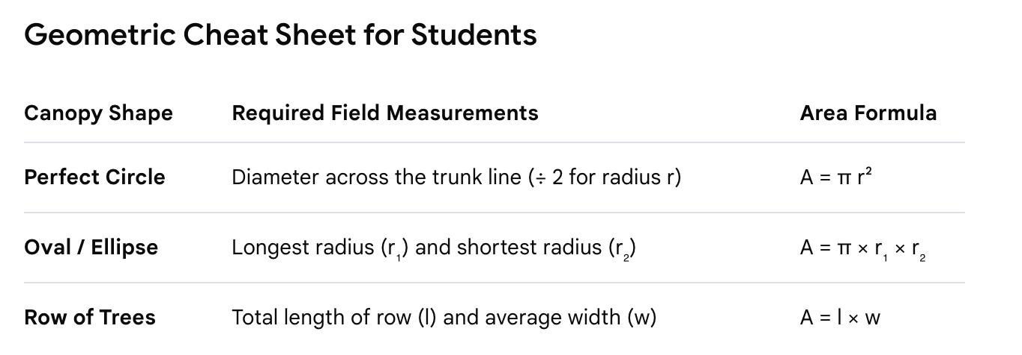
- Compare site canopy cover with the ideal percentage in a desert environment/City of Tucson goal (15% goal).

Lesson 4: Design a Solution - What can we do with this information?

What did our data tell us? Would our site benefit from more canopy cover?
- Brainstorm ideas to create more canopy cover at a site. Which trees provide the most shade? Which trees would provide the best services for our school and local wildlife? Where would you put the trees?
- What will increased canopy provide at this site?
- Where else can you apply this?

Reflection and Closure:
Create a one-pager of your learning.
Benefits of trees
Measuring canopy
Heat Island Effect

